  - NHS Equality Delivery System 2022

EDS Reporting Template
Version 1, 15 August 2022

Classification: Official
Publication approval reference: PAR1262

Equality Delivery System for the NHS
The EDS Reporting Template

Implementation of the Equality Delivery System (EDS) is a requirement on both NHS commissioners and NHS providers. Organisations are encouraged to follow the implementation of EDS in accordance EDS guidance documents. The documents can be found at: www.england.nhs.uk/about/equality/equality-hub/patient-equalities-programme/equality-frameworks-and-information-standards/eds/
The EDS is an improvement tool for patients, staff and leaders of the NHS. It supports NHS organisations in England - in active conversations with patients, public, staff, staff networks, community groups and trade unions - to review and develop their approach in addressing health inequalities through three domains: Services, Workforce and Leadership. It is driven by data, evidence, engagement and insight.
The EDS Report is a template which is designed to give an overview of the organisation’s most recent EDS implementation and grade. Once completed, the report should be submitted via england.eandhi@nhs.net and published on the organisation’s website.

Name of Organisation |  | Calderdale and Huddersfield NHS Foundation Trust | Organisation Board Sponsor/Lead
Rob Aitchison, Health Inequalities
Suzanne Dunkley – Workforce EDI
Name of Integrated Care System |  | West Yorkshire

NHS Equality Delivery System (EDS)

EDS Lead | Alex Keaskin, Patient EDI  Nicola Hosty, Workforce EDI |  | At what level has this been completed?
 |  |  |  | *List organisations
EDS engagement date(s) | 4, 11, 15 December 2023 (Domain 1) and 28 February 2024 Domain 2 and 3) |  | Individual organisation
 |  |  | Partnership* (two or more organisations)
 |  |  | Integrated Care System-wide* | Yorkshire Ambulance Service, Mid Yorkshire Hospitals NHS Trust, Calderdale & Huddersfield NHS Foundation Trust, West Yorkshire ICB – Kirklees, Wakefield, Calderdale Place

Date completed | March 2024 | Month and year published | March 2024
Date authorised | March 2024 | Revision date

Completed actions from previous year

EDS Organisation Rating (overall rating): Achieving
Organisation name(s): CHFT
Those who score under 8, adding all outcome scores in all domains, are rated Undeveloped

Those who score between 8 and 21, adding all outcome scores in all domains, are rated Developing

Those who score between 22 and 32, adding all outcome scores in all domains, are rated Achieving

Those who score 33, adding all outcome scores in all domains, are rated Excelling

CHFT Domain 1 Presentation Scores

4th December Presentation – Smoke Free Pregnancy Pathway - Stakeholder Score – Achieving

11th December Presentation – Children & Young People’s Mental Health: Promoting Inclusion - Stakeholder Score – Achieving

15th December Presentation - Addressing the health inequalities and enhancing the patient journey for people with learning disabilities – Stakeholder Score – Achieving

CHFT Domain 2 & 3 Presentation Scores

28th February 2024 - Stakeholder Score – Achieving - Health & Wellbeing and Inclusive Leadership

The NHS Long Term Plan (2016) requires Trusts to provide stop smoking support to in-patients, and the pathway should be adapted for pregnant women and families.
Smoking is the single most important modifiable risk factor contributing to poor pregnancy outcomes. It is associated with preterm birth, fetal growth restriction, miscarriage, stillbirth, and sudden unexpected death in infancy as well as a number of other longer term childhood health conditions.
CHFT in house stop smoking service for pregnant women launched in October 2022 and was the first Trust in West Yorkshire to fully implement (to 100% of women).
In the first 12 months of providing the new service smoking at time of delivery has reduced from 10.62% to 7% (year to date).

Domain 1: Commissioned or provided services
Service 1 – Smoke Free Pregnancy Pathway – Presentation held 4th December 2023

Domain | Outcome | Evidence | Rating | Owner (Dept/Lead)
 |  | CHFT Smokefree Pregnancy Service launched in October 2022 and was the first Trust in West Yorkshire to fully implement in-house services to 100% of women.  How it works:  - Two Maternity Health Advisers appointed to deliver the service.  - Training with National Council for Smoking Cessation Training and Yorkshire Smokefree to achieve Level 2 Stop Smoking Adviser Qualification. Contact every pregnant woman who is a smoker, within 24 hours of their pregnancy booking appointment, to offer them support to quit smoking. | Achieving | Kate Heighway
Domain 1: Commissioned or provided services | 1A: Patients (service users) have required levels of access to the service | 1A: Patients (service users) have required levels of access to the service.  Evidence What does this show  1 table & graphs see below Data shows that most women who smoke in pregnancy are white British, or white (other) living in areas of high deprivation IMD codes 1,2,3,4,5. Graphs of IMD codes at booking and discharge show a reduction in smoking for women living in IMD codes 1,2,3,4,5  Evidence  1. Ethnicity of women using the service  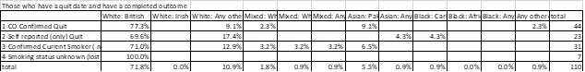  IMD codes all smokers / non-smokers at booking and discharge.  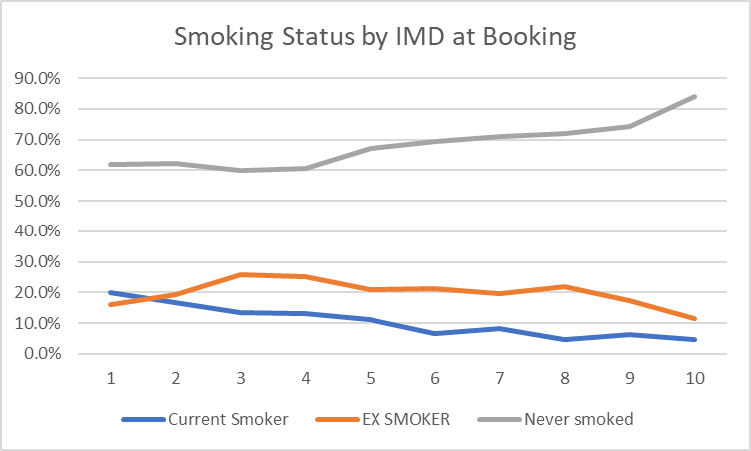  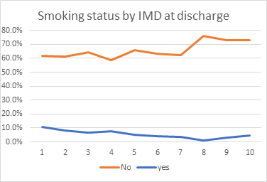
 | 1B: Individual patients (service users) health needs are met | 1B: Individual patients (service user’s) health needs are met.  Evidence What does this show  Smokefree Pregnancy Pathway Sets out how the pathway works to meet individual health needs.  All pregnant women are screened with a Carbon Monoxide (CO) breath test at booking and given very brief advice about smoking.  Opt-out referral to the in-house service – Maternity Health Advisers.  Contacted within 24 hours by phone or text to offer service.  Free Nicotine Replacement Therapy (NRT) posted out, set Quit date.  12 weeks personalised support and further NRT supplies.  28 days after Quit date – CO screening and Certificate.  ALL women CO test at ALL maternity appointments.  In 2020 we initiated research in Kirklees working with the University of Huddersfield. Researchers asked women who smoked during pregnancy what support they thought we should provide to help them quit smoking.  Published in ‘Women and Birth’ Tomasina Stacey, et al (2021) ‘I don’t need you to criticise me, I need you to support me’. A qualitative study of women’s experiences of and attitudes to smoking cessation during pregnancy.  Our approach is to provide a holistic and personalised supportive service, friendly and non-judgmental, building trust and developing relationships. We listen, and work ‘outside the box’ supporting with mental health, preparing for baby etc responding to identified needs of the woman.  Women who would not usually access services:  Work alongside the Midwife for Substance Misuse. Multi-agency clinic and parent education group. Most women smoke cannabis and have mental health issues.  - 17 women accepted service.  - 3 women have quit, 3 more still working towards quit.  - Removing barriers to care.  Women living in areas of social deprivation:  - Offer face to face clinics / home support as necessary.  - Support to sign up to Healthy Start voucher scheme.  - Encourage to attend hospital appointments if reluctant.  - Source baby equipment & clothing.  - Offer and respond to calls for help, when women are having a bad day  Oct 22-March 23  - 75% of smokers contacted within 24 hrs (25% did not respond).  - 64% of all women eligible engaged to some extent with the offer of support to quit smoking.  - 36% set a Quit date.  - 26.58% Quit smoking.  - 72.4% Quit rate (of those who set a quit date).  In the first 12 months of providing the new service smoking at time of delivery has reduced from 10.6% to 6.9% (year to date).  The smokefree pregnancy pathway is delivered within maternity services providing an equitable service to pregnant people regardless of their age, disability, gender reassignment, marital status, race, religion, belief or sexual orientation.  Local data shows that most women who smoke at booking are White British (71%) age under 25, living in IMD 1,2,3,4, and often live with other smokers.  The service and plan of care is personalised to each client and adapted to their individual needs and delivered in line with their wishes.
 | 1C: When patients (service users) use the service, they are free from harm | 1C: When patients (service users) use the service, they are free from harm.  Evidence What does this show  Smokefree Pregnancy Pathway Sets out how the pathway works to reduce risk of harm from smoking to mother and baby.  2 The Smokefree Pregnancy service at CHFT provided case studies for the West Yorkshire HCP website, see below: Stories from other women :: West Yorkshire Health & Care Partnership (mums-can.co.uk)  Emily (aged 25)  At the start of my pregnancy, I was smoking three to five cigarettes a day as I was finding it difficult to stop smoking. As my pregnancy went along and Naomi (Maternity Health Adviser at Calderdale and Huddersfield NHS Trust) got in contact with me with support to help me stop smoking, I started to make moves myself after being told the risk factors it has on my baby. I chose to have tea or coffee instead of a cigarette.
 | 1D: Patients (service users) report positive experiences of the service | 1D: Patients (service users) report positive experiences of the service  Evidence What does this show  2 - link see below Case studies on West Yorkshire ICB #MumsCan website showing women’s experience of care at CHFT.  Example 1  It was around week 31/32 when Naomi got in contact, and I lost hope and thought it was too late to be able to stop.  Naomi then offered me a nicotine inhalator and patches which I used when I felt like a cigarette. By week 36/37 I was having one cigarette a day, not because I felt like it but because it was more of a habit of having something in my mouth and smoking. I feel like the inhalator helped me more than the patches.  I fully stopped smoking around five weeks before I had my baby, my baby is now 6 weeks old. I never thought I was going to do it as my husband also smokes and I found it really hard when he was smoking around me, but with the support from Naomi and telling myself I can do it, not for me, but for my baby. I did it.  Naomi was fantastic with her support and went the extra mile. I was suffering with severe morning sickness, so she posted my patches out to me on two occasions, and then left them weekly with my midwife to collect when I had my appointments. Thank you so much for your support!  Example 2  23 year old Joanna is expecting her first baby and lives at home with dad, who is also a smoker. Before getting ready to go to work, Joanna would make a brew and roll up a cigarette at the start of the day. The number of roll ups she smoked during the day would vary although usually not more than 10.  When Joanna found out she was pregnant, she initially declined any support to quit. However, at 16 weeks and following a conversation with Maternity Health Adviser, Naomi, about lifestyle, smoking habits, healthy eating during pregnancy and vitamins, together they agreed a care plan. That care plan included weekly support on the phone and nicotine replacement therapy (NRT) patches through the post. Joanna would put a patch on in the morning and keep it on for the recommended 16 hours and used a vape when she needed to.  Although Joanna struggled to give up at first, thanks to the patches, she cut down on her tobacco use and agreed 14 March 2023 would be the day to quit altogether. When 14 March arrived, Joanna removed all temptation from view and applied a patch as soon as she got up. Naomi was delighted to get a text from Joanna saying that she’d gone all day without smoking.  Naomi also offered to refer Joanna’s dad to an external stop smoking service but he didn’t want to take up that offer. Instead, Joanna made him aware of the risk of passive smoking to her and baby’s health and asked him to go outside when having a cigarette.  After five weeks of using the patches Joanna felt she no longer needed them. Naomi was there every step of the way to encourage Joanna and offer support when she had a wobble or felt anxious. Carbon monoxide readings dropped massively to a safe level. Exposure to carbon monoxide, which can be caused by smoking during pregnancy, affects a growing baby’s access to oxygen, which is needed for healthy growth and development.  On the feedback form, Joanna said:  “Naomi has been so supportive throughout my journey to stopping smoking, checking in regularly and offering me great advice and reassurance every time we spoke. She made me feel confident that I could speak to her if I had any other concerns or needed any other support throughout. She also sent me some vitamins which helped massively. I’m not sure I’d have managed to get to this stage without her support! She’s a credit to the NHS!”  Joanna is delighted to be a non-smoker and knows that she can contact Naomi if she needs any more support. This mum can – and did.

Domain 1: Commissioned or provided services
Service 2 – Children & Young People’s Mental Health: Promoting Inclusion – Presentation held 11th December 2023
Domain | Outcome | Evidence | Rating | Owner (Dept/Lead)
 |  | Children and young people’s mental health may impact on their ability to access physical health care. Children and young people’s physical health may impact on their mental health and wellbeing. Children and young people’s physical, psychological, and social care are organised separately, and we want to do better to integrate this and make the system more inclusive and easier to navigate.  Evidence used is based on the research collated by the team, and case studies from patients | Achieving | Ian Noonan – Consultant Nurse for Mental Health
Domain 1: Commissioned or provided services | 1A: Patients (service users) have required levels of access to the service | How does it work?  - Multi-factorial intervention mirroring systemic approach in child and adolescent mental health care  - Mental Health Consultant Nurse appointed Sept 2022  - Paediatric Mental Health Liaison Sister appointed Nov 2022  - Review of CYP awaiting admission to a mental health bed in acute trusts – cross region thematic review  - Designed and built self-harm screening for all children and young people admitted to CHFT - Public Mental Health Promotion  - BLOSM launched December 2022 – Public Mental and Social Health Promotion for CYP  - Policy and guideline review and development  - Mental health support worker and mental health champion funding  - Vignette – from concern to protocol – co-constructed interventions  - Children and young people’s mental health professional summit Feb 2024  Reports and data: Hawton et al 2012, Mars et al 2016, Fortune, Sinclair & Hawton 2007, Fortune, Sinclair & Hawton 2007, O’Reilly & Kiyimba 2016, 2018  Self Harm screening for all Children and Young Persons – Why?  - Screening is brief, important, supports the public health needs in relation to self-harm of our population of CYP, and can be incorporated into the past medical history section of the admissions assessment with minimal impact on workload.  - Discovering that a CYP is self-harming or experiencing suicidal thoughts will require follow-up, but it may help reveal co-occurring social and psychological issues that are likely to impact on the CYP health, wellbeing and recovery.  The screening being carried out with every child and young person who is admitted means that everyone has the chance to access the mental health support available to them, instead of it being left to chance/individuals bringing the conversation into their appointment  - Children living with a mental illness or physical illness that impacts on their functioning for more than a year could be considered to have a disability. Integrating mental and physical health care limits the impact of diagnostic overshadowing and promotes inclusion.  - Children who are Asian, Black and other ethnically diverse young people do not have a decreased prevalence of self-harm but are under-represented in secondary mental health services. Screening is a public health intervention that can help mitigate unconscious bias and contribute to equality of access to services.  - 59% of Lesbian, Gay, Bisexual, Transgender, Queer and Intersex young people have considered suicide and 48% have self-harmed at some time. Not asking about this risks further conveying that there is a part of that young person’s identity that we do not want to know about or acknowledge. It is an important intervention to decrease the increased prevalence of injury and death in these young people who may already feel marginalised or excluded.  - In some faith groups it remains very difficult to acknowledge thoughts about self-harm or suicide within the family and being asked privately whilst in hospital, gives the young person an opportunity to discuss these thoughts and feelings. |  | ​
 | 1B: Individual patients (service users) health needs are met | Why ask about Self Harm in Hospital?  - Hospital admission provides an opportunity to ask CYP about their self-harm.  - In general, CYP want to be asked, sensitively, privately, and have the opportunity to discuss it (Fortune, Sinclair & Hawton 2007)  - Self-harm is often linked to other social problems such as bullying, problems at home, psychosocial stressors, and stigma may act as a barrier to seeking help (Fortune, Sinclair & Hawton 2007)  The importance of inclusive language:  - Introduce topic slowly via how is your mood/how do you feel today – funnelling technique  - “This is something we ask everyone…don’t worry if it does not apply to you” O’Reilly & Kiyimba 2016  - “I’ve noticed [a change in behaviour or a scar or sign of self-harm]…and I wonder if things are difficult for you at the moment”. Or  - “I’ve noticed you keep your [part of body – e.g. arms covered] and I know this can sometimes be a sign that someone has harmed themselves. Can I ask you if you have self-harmed?  Age Appropriate Questioning:  - 4-7: “sometimes when children feel big emotions they hurt themselves – have you ever felt like that?” or “sometimes people hurt themselves when they are upset – do you ever do that?”  - 8-13: “sometimes when people don’t know how to manage how they feel inside they might try hurting themselves – have you ever done that?” or “if you were feeling something unpleasant do you ever think about hurting yourself?”  - 14+: CYP are more likely to have heard about self-harm at school, on social media or from friends, so more direct questions may be OK – “have you ever had thoughts about self-harm?” and “have you ever hurt yourself in any way?”  Hugo was treated and supported with his coeliac disease in a way which meant his mental health wasn’t negatively impacted
 | 1C: When patients (service users) use the service, they are free from harm | The screening ensures the non presenting mental health risks in the community aren’t being missed to the level they are currently, such as:  - Self-harm and suicide are a major public health concern in adolescents  - Self-harm rates are high in teenage years  - Suicide is the second most common cause of death in young people worldwide (Hawton et al 2012)  - Self-harm prevalence rates in CYP are underestimated  - Only 1.8% of CYP who (or their families) reported self-harm had at least one hospital record/ED attendance for self-harm  - 66% of CYP admitted to hospital following self-harm had no corresponding ED record for self-harm  - In essence we do not know the prevalence of self-harm in CYP in our community and it is under-reported both in hospitals and in self-reporting scales (Mars et al 2016)
 | 1D: Patients (service users) report positive experiences of the service | Lasting Impact:  - Paediatric outpatients have led on a working group to develop a protocol to support CYP with phobias, particularly focussing on venepuncture for the time being.  - They have engaged the lab teams who are exploring being part of Harvey’s Gang, which supports lab tours for young people, both promoting interest in hospital and biomedical science careers, but also has been noted to impact on reducing hospital anxiety and fear.  - A colleague who is completing their Low Intensity Wellbeing Practitioner (IAPT) training has, with supervision, assessed and treated Hugo with CBT techniques to help manage his worry.  - Hugo’s experience has informed the protocol development and he and his mum have agreed to present at a CYP Mental Health Professionals Summit being hosted at CHFT in Feb 2024.  Self-harm screening for Children & Young People is now one of our Key Performance Indicators that will be reported to the Trust’s Clinical Outcomes Group  Example 1: 11-year old with coeliac disease. He takes a keen interest in the management of his diet and other factors to maintain his health, but also has a severe needle phobia. He had not had required blood tests for two years and there had been some oversights (using a numbing cream on one arm then taking bloods from the other, for example) that had contributed to him losing confidence in our outpatients. Mum wrote to PALS with a complaint. We did not have a protocol to support CYP with needle- or other hospital-phobias, so colleague met with the 11 year old and mum to: -do an assessment; -refer to local CYP psychological services; -help devise an hospital passport with Hugo that is specifically about tests; negotiate that he could continue in Paediatric outpatients rather than transfer to adult phlebotomy at present; -liaise with his consultant to identify which test could be managed through finger pricks, and discussed with our laboratory teams and paediatric outpatients, what else might be done.

Domain 1: Commissioned or provided services
Service 3 – Addressing the health inequalities and enhancing the patient journey for people with learning disabilities– Presentation held 15th December 2023
Domain | Outcome | Evidence  The Learning Disability Mortality Review Programme (LeDeR) annual report (2019) highlighted people with learning disabilities die from avoidable medical causes of death twice as frequently as people in the general population (44% of deaths of people with learning disabilities; 22% of deaths in the general population). The greatest difference between people with learning disabilities and the general population was in relation to medical causes of death, which are treatable with access to timely and effective healthcare. A third (34%) of deaths of people with learning disabilities were from treatable medical causes, compared to only 8% in the general population.  COVID-19 death rate for people with learning disabilities was 240 deaths per 100,000 adults. 2.3 times the rate in the general population for the same period. further widening the health inequalities gap and causing health disadvantages for people with learning disabilities.  Evidence consistently highlights that people with a learning disability have poorer physical and mental health than the general population and experience greater health inequalities. Many of these individuals also have complex needs and severe anxiety about health interventions, struggling to access healthcare services, not accessing healthcare in a timely manner or in some cases not at all, which in turn can be detrimental to the individual’s health and wellbeing.  The Trust committed to improving the lives of people with a learning disability and the health inequalities agenda, with CHFT since being recognised nationally as leaders in health inequalities specifically for people with learning disabilities. | Rating | Owner (Dept/Lead)
 |  |  | Achieving | Amanda McKie, Consultant Nurse Learning Disabilities
Domain 1: Commissioned or provided services | 1A: Patients (service users) have required levels of access to the service | In recent years CHFT has developed a robust flagging system to better identify patients who have a learning disability and analyse local data to better support the needs of patients. Since this development, the cohort of patients with a learning disability known to us from the local population has consistently increased. In 2021 the knowledge portal (KP+) used the learning disabilities flag to develop the learning disabilities model, which for the first time enabled us to compare data from patients with learning disabilities with the general population. This then has allowed us to identifying local problems, track patient journeys, highlight themes and trends, detect and locate problems and likewise target improvement.  - CHFT has developed the LD flag and dashboard to monitor the activity of patients accessing services.  - CHFT has undertaken deep dives and Audits to look at the barriers of accessing services and put improvement methodology in place  - CHFT is working with expert by experience and people with learning disabilities on the changes required, and improvement work – such as Think Learning Disabilities and ED care bag  - CHFT is undertaking service improvement projects to ensure the disparity is addressed such as reducing DNA rates  - CHFT has the VIP hospital passport and care plan for people with a learning disability  - CHFT has the Think Learning Disability campaign  - CHFT has achieved 95% mandated learning disability training for the Trust |  | Amanda McKie​
 | 1B: Individual patients (service users) health needs are met | The trust developed and implemented a range of tools to identify those with a learning disability, understand their experiences and monitor the differences being made.  - Flagging system within patient records  - Learning Disability data dashboard  - Data models offering comparisons with general population  - Deep dive into patient journeys from referral to treatment  - Audits on the reasonable adjustments made  - Audits on cancer data  - Audits on missed appointments  - Looked at information on readmissions, length of stay and mortality  The data enables us to identify areas for targeted action  - Prioritised people with a learning disability who were waiting for surgery  - Including working with special needs dental services to restart theatre sessions and increase capacity to reduce the backlog on waiting lists  - Identified inequalities in length of stay for learning disabilities compared to general population in medicine  - Increased readmission rates for patients with learning disabilities  - Identifying potential inequalities within A&E 4hour target  - Several deep dive audits lead by clinicians  Engagement with self-advocates and expert by experience – ensuring we were inclusive using easy read agenda, minutes and listening.  We identified by reviewing the data that patients with a learning disability use services differently, one intervention to support patients with a learning disability was to introduce A&E Care bags to CHFT on the back of a successful pilot in Leeds. Funded by CHFT Charity.
 | 1C: When patients (service users) use the service, they are free from harm | Engagement with self-advocates and expert by experience – ensuring we were inclusive using easy read agenda, minutes and listening.  - Ensuring that learning disabilities is everyone’s business  - Learning Disability awareness training compliance is 95% within 12 months  - Learning Disability awareness film produced  - Refreshed the learning disability awareness leaflet  - 412 Think Learning Disability champions and growing  - Utilising Learning Disability Week in June  - Working closely with self advocates to make the data meaningful to them.  - Go back for feedback and make changes again to ensure we get it right
 | 1D: Patients (service users) report positive experiences of the service | Reviewing data led to divisional audits to address inequalities for patients with learning disabilities, influencing improvement work and enabling processes to be implemented in specific areas to better identify and understand patients who have a learning disability, to enable reasonable adjustments to be made and improve their care and patient experience. LD and health inequalities data is now captured on Integrated Performance Report to Board on monthly basis for continuous monitoring and Oliver McGowan Learning Disability and Autism training is currently being implemented across the trust.  Our work has been recognised regionally and CHFT were asked to lead on the reset and recovery work for WYAAT, the Elective Care Group (ECG) received a presentation from the Trust and following discussion it was decided the regional Access policy with be changed to prioritise people with a learning disability across West Yorkshire on P3 and P4 waiting lists.  CHFT established a Health Inequalities Group chaired by the deputy chief executive to oversee development and delivery of workstreams and actions to address health inequalities. The work has involved widening the health inequalities lens, reviewing waiting lists to identify and address any inequality using recent KP+ models. These new models for health inequalities include IMD, Ethnicity and frailty data. The group has also produced a DNA prediction tool, social vulnerability matrix and deep dives into health inequalities which have been presented to health inequalities meetings and individual divisions.  The group has influenced other new projects including Patient communication project looking at the quality of communication the trust sends to patients with a focus on quality, accessible information, DNA and patient experience. A pilot has begun looking at Robotic Process Automation (RPA) and how this can be used to identify patients with a learning disability flag and share information regarding their learning disability and any reasonable adjustments to the appropriate clinician to better meet their needs. The trust continuously works with Calderdale ICB around Population Health management.

Domain 2:  Workforce health and well-being | 2A: When at work, staff are provided with support to manage obesity, diabetes, asthma, COPD and mental health conditions | Spotlight on Occupational Health Colleagues are provided with support to manage obesity, diabetes, asthma, COPD and mental health conditions upon receiving a management referral into the OH service.  During the period April 2022 to March 2023, occupational health received specific referrals as follows:  Respiratory illness 16  Obesity 0  Diabetes 0  Mental health 266  It is important to note that as clinicians take a holistic approach, they often assess clients with these conditions even when the primary referral reason was something different.  Our General Wellbeing offer focuses on financial, social, physical and mental wellness  Our core wellbeing interventions are our internal Wellbeing Connect service and the Employee Assistance Programme hosted by Vivup, who provide free wellbeing support 24/7, 365 days a week.  We have hosted two wellbeing festivals throughout 2023 focussing on themes such as stress and TALK (tiny acts of loving kindness). These events help the wellbeing team to connect with colleagues to highlight where colleagues can come to if they need some wellbeing support and discuss issues such as mental health, financial wellbeing and general dietary advice and fitness. Over 360 colleagues attended.  We have 87 wellbeing ambassadors in the organisation who are colleague volunteers who support teams locally and connect people to support quickly.  CHFT worked with West Yorkshire Health and Care Partnership to become a Menopause Accredited Friendly Employer in 2023. We have a Change Society (menopause) peer support network with 94 members, and they have been influential to support the organisation to ensure we have a menopause policy and gained the accreditation.  We have a dedicated colleague psychology team who are trained in EMDR and help inform our people approach through a psychological lens. The team have led a programme where 14 colleague volunteers are trained to host critical event peer support debriefs in the organisation.  There were four Schwartz Rounds held in 2023 with topics including, ‘a day in the life of’, ‘why I do the job I do’, ‘tales of the unexpected’ and ‘scary moments’. 64 colleagues accessed the rounds in 2023.  Colleague wellbeing is one of the most talked about subjects on walk rounds. This feedback helps us to focus on reviewing and developing our approach.  We have designed a comprehensive wellbeing offer (including the benefit of a weekly wellbeing hour) that provides our colleagues the opportunity to sustain their workplace health and wellbeing. The offer focuses on four themes social, physical, financial, and mental. Activities include:  - Engaging, clear communications –supporting “it’s okay not to be okay” and reducing the stigma of mental health.  - Induction  - Refreshed appraisal approach including wellbeing check-in, including improved conversations regarding colleague development.  - Compassionate leadership programme – role modelling, harness curiosity, create time and space to talk.  - Connect and Learn Session – Health & Wellbeing Conversations  - Men’s health week roadshow  - 5 a side football tournament  - Top up shops – discreet food banks / recycled clothing for colleagues  - Cost of Living – focus on financial education, access to low-cost loans through salary finance, credit union and wagestream  - SS Dance and Fitness - weekly sessions held on site.  - Wellbeing and relaxation sessions with medicine directorates in conjunction with local businesses  - Wellbeing and Engagement calendar of events One Culture of Care Calendar - One Culture of Care Event Calendar (pagetiger.com)  - Flexible/Agile Working options  - Menopause peer support group including education and advice  - Equality peer support groups  - Check in and Check out Framework  - Reduced Rate gym memberships  - Wellbeing hour | Achieving | Nicola Hosty, AD of WOD
 | 2B: When at work, staff are free from abuse, harassment, bullying and physical violence from any source | Results from the 2023 staff survey highlight that colleagues are reporting:  Not experienced harassment, bullying or abuse from patients/service users, their relatives or members of the public:  2022 - 73.6% 2023 - 72%  Not experienced harassment, bullying or abuse from managers:  2022 - 91.5% 2023-– 91.4%  Not experienced harassment, bullying or abuse from other colleagues:  2022 - 82.9% 2023 - 82.2%  Last experience of harassment/bullying/abuse reported:  2022 - 47.3% 2023 - 47.7%  Staff survey data highlights that the position remains static.  Tools that have been implemented to support colleagues are:  - Violence and Aggression policy  - Freedom to speak up portal and ambassadors  - Workforce Race Equality Standard and Workforce Disability Equality Standard data analysis and supporting action plans  - Race Equality Network Peer Support Group
 | 2C: Staff have access to independent support and advice when suffering from stress, abuse, bullying harassment and physical violence from any source | - Employee Assistance Programme portal and counselling service  - Wellbeing Connect  - Freedom to Speak up channels  - Wellbeing Ambassadors  - Union relationships  - Signposting to external resources
 | 2D: Staff recommend the organisation as a place to work and receive treatment | Staff Survey 2023 results compared to 2022 staff survey results showed:  Would recommend organisation as place to work:  2022 - 56.8% 2023 - 62.8%  If friend/relative needed treatment would be happy with standard of care provided by organisation:  2022 - 64.2% 2023 - 66.9%  Positive improvement from the previous year  Positive scores against the benchmark average

Domain | Outcome | Activity | Rating | Lead
Domain 3:  Inclusive leadership | 3A: Board members, system leaders (Band 9 and VSM) and those with line management responsibilities routinely demonstrate their understanding of, and commitment to, equality and health inequalities | A number of board members, system leaders (Band 9 and VSM) are an Executive Sponsor of the equality networks (Pride, Disability, Womens Voices and Race Equality Network)  We have developed an inclusion group that includes Board members, system leaders (Band 9 and VSM) who ensures that:  All inclusion activity is aligned to One Culture of Care  We adopt a Trust wide view as well as focus attention on a service and/or colleague group perspective  We focus on how Equality, Diversity & Inclusion (ED&I) activity that can help delivery of Trust objectives and priorities  We advocate a multi-disciplinary approach to ED&I activity and engagement  We focus attention on clinical and non-clinical work groups  We look at providing an outstanding colleague experience for all  We work collaboratively  We accept we are all learning more about the ED&I agenda as we progress the conversation  Those with line management responsibilities have access to an equality, diversity and inclusion education suite available through management fundamentals learning platform. EDI modules are included in the New to Manager and Empower programmes.  A Board diversity action plan is developed and equality, diversity and inclusion is discussed regularly at Workforce Committee.  Equality, Diversity and Inclusion is also a chapter in the people strategy | Achieving
 | 3B: Board/Committee papers (including minutes) identify equality and health inequalities related impacts and risks and how they will be mitigated and managed | We have a health inequality network that is chaired by the Deputy Chief Executive that focuses on the following Health Inequality Actions:  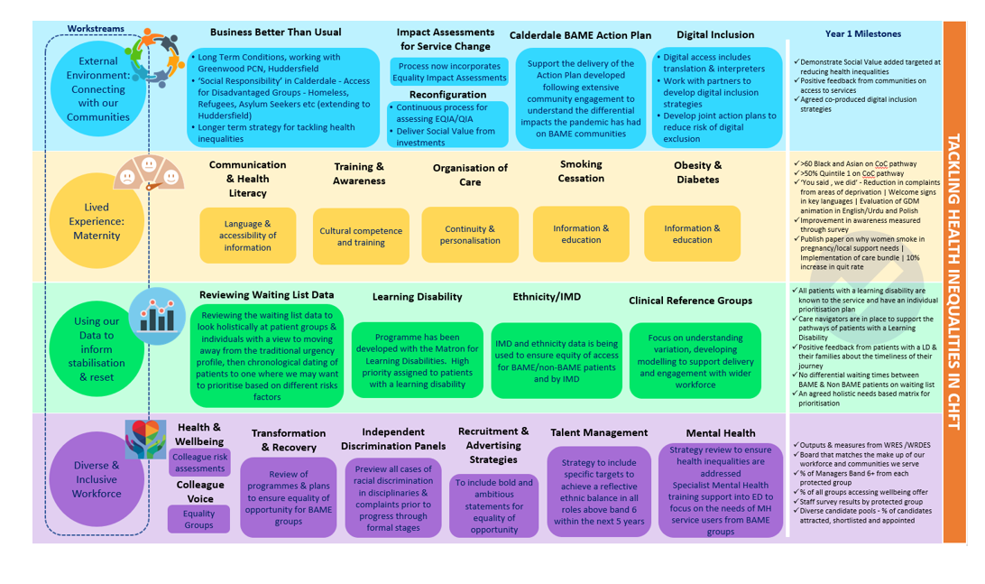  Outputs from the health inequality network are shared with the Board
 | 3C: Board members and system leaders (Band 9 and VSM) ensure levers are in place to manage performance and monitor progress with staff and patients | Equality Impact Assessments and Quality Impact Assessments are expected to be undertaken for all papers.  Health inequalities, equality diversity and inclusion for patients and workforce and discussed periodically with board members and system leaders.

